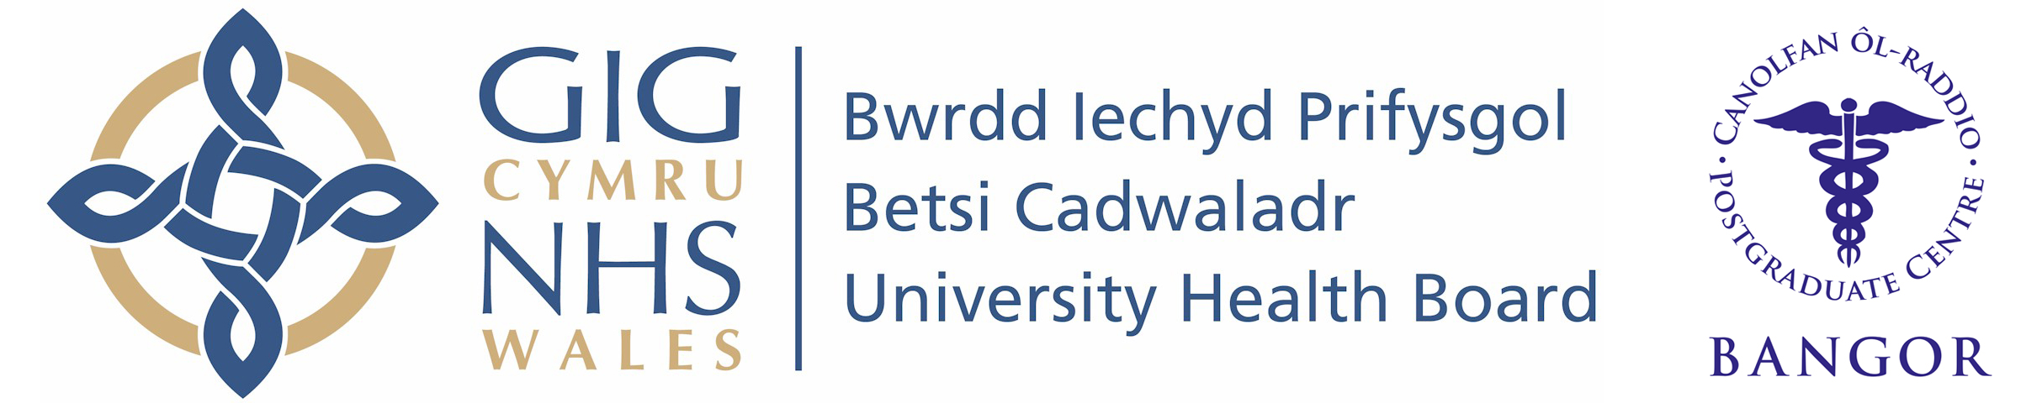
Wales Foundation School
Individual Placement Description

Placement
F2 Oncology

What type of work to expect and learning opportunities:

If you choose to join the F2 rotation through the Alaw Unit you can expect to work alongside a multidisciplinary team who are all pulling together to ensure that our patients get the best care. You will gain experience in Haematology, oncology and palliative care in both inpatient and outpatient settings with additional opportunities to gain a taste of palliative care out in the community. There is a high level of senior support throughout the placement and our extremely experienced specialist nursing team are very supportive of our doctors in training. Due to our commitment to both postgraduate and undergraduate education, there are ample opportunities for personal development, whether that be in the form of attending education sessions, delivering bedside teaching or running educational programs of your own. There are also opportunities for QIP and research projects, we will support you throughout these projects and help you to achieve success; some of previous F2s have gone on to be present their work at national conferences. If you want to join a friendly, cohesive and supportive team which will help you to not only achieve your potential but will also take an interest in what is important to you this is the post for you.

Clinical Supervisor: Dr A P Mullard

It is important to note that this description is a typical example of your placement and may be subject to change.

