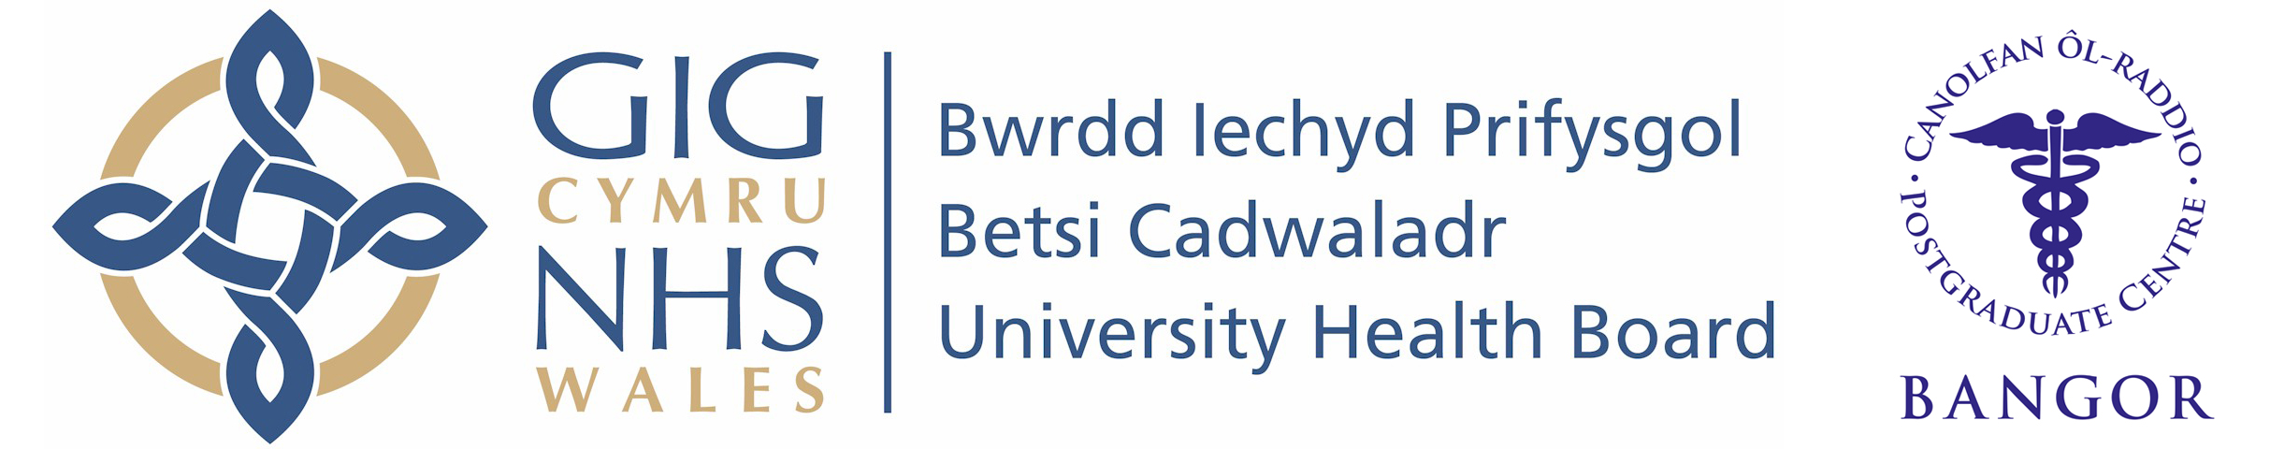
Wales Foundation School
Individual Placement Description

Placement
F2 Psychiatry

What type of work to expect and learning opportunities:

During this placement, you will be exposed to 2.5 days of Liaison Psychiatry( assessing and reviewing people presenting with mental health issues in A&E and general wards at Ysbyty Gwynedd) and 2 days of Forensic Psychiatry(reviewing inpatients in the medium secure unit in Ty Llwellyn and opportunities to shadow consultant assessing people in other settings including prisons). During your on-calls you will be involved in the care of inpatients, provide support to the liaison and home treatment team.

You are expected to work with curiosity and exhibiting genuine interest in the lives of the people that you review; becoming involved in the multidisciplinary working as a valued team member. There will be opportunity to be involved in medical education (presenting cases/papers in the divisional teaching session, providing teaching sessions to medical students and nurse prescribers) and quality improvement project. There is also weekly supportive Balint Group for you and the other junior doctors (https://balint.co.uk/about/introduction/).
Clinical Supervisor: Dr Khalid Sani

It is important to note that this description is a typical example of your placement and may be subject to change.

