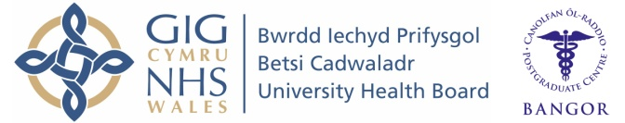
Wales Foundation School
Individual Placement Description

Placement
F2 Anaesthetics

What type of work to expect and learning opportunities:

Join a warm, welcoming and cohesive department.
Leave with pride in having acquired the fundamentals to provide anaesthetic care to patients undergoing surgery.

A unique opportunity to have almost daily one-to-one teaching.

Learn or develop invaluable and transferable skills such as advanced airway and ventilation techniques, invasive line insertion, communication skills and team working under pressure. Weekly formal teaching sessions on Anaesthetics and ICM topics supplement knowledge learnt on the job.

You will be a member of the on call theatre and critical care teams and spend a two week attachment in critical care. You will gain confidence in working in multidisciplinary teams assisting the stabilisation of acutely unwell patients.
You will hone your skills in delivering concise yet comprehensive handovers of patients.

You will also gain experience in Obstetrics, and Acute & Chronic Pain management.

There is plenty of opportunity to be part of audits or quality improvement projects.

Above all, you will gain an insight into the varied and satisfying career that Anaesthesia and Critical Care has to offer.
Clinical Supervisor: Dr Stephan Clements

It is important to note that this description is a typical example of your placement and may be subject to change.

