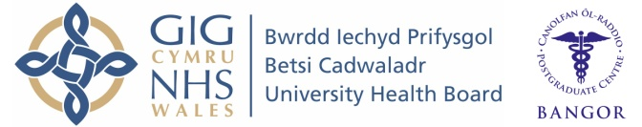
Wales Foundation School
Individual Placement Description

Placement
F2 T&O

What type of work to expect and learning opportunities:

The Orthopaedic and trauma unit here in Ysbyty Gwynedd is a relatively busy site taking injured patients from the great outdoors of North Wales and Snowdonia including water sports and other past times and it is in addition a busy retirement area with a somewhat aging population running into problems associated with successfully surviving middle adult hood.

There is a busy elective unit in addition encompassing major joint replacement surgery, day case and sub specialties including hand, foot and ankle services and revision arthroplasty.

Our junior trainees rotate through other parts of the hospital including the Emergency Department and General Surgery and there are efforts made to provide useful and satisfying study leave opportunities to further the career progression of our juniors
Clinical Supervisor: Mr. S. Griffin

It is important to note that this description is a typical example of your placement and may be subject to change.

